Week In Review: Catching Up
Alex Shvartsman
Because of the Magic Invitational held in Australia, I was unable to access the Internet and gather news, rumors and cool stories that make up this column. Thus, this issue will cover everything that happened over the last two weeks.

Grand Prix: Phoenix, Kyoto and Sydney
The Extended season is well under way. The metagame is settling and it seems that no one deck has a clear advantage against the field. In Phoenix, Sean Fitzgerald's CounterSliver deck defeated Sean Smith's Oath deck in the finals. Although it was generally accepted that NecroDonate was the strongest deck in the format prior to that weekend, none of the Trix decks made it into the Top 8. Instead, it was a field of CounterSlivers and 5-color-Donais for the most part.
Plenty of Trix decks finished in the money even if none made Top 8. Some of the other interesting decks included Dave Williams' variant of TurboLand that used red for Obliterate and Pyroblast (9th place). Dan and Steve OMS achieved 10th and 31st place finishes with their version of Hatred. Despite Dark Ritual missing from the environment, their deck did well. They substituted Lake of the Dead for the Dark Ritual. It would not offer amazing first turns, but could still help cast a turn 3 Hatred.
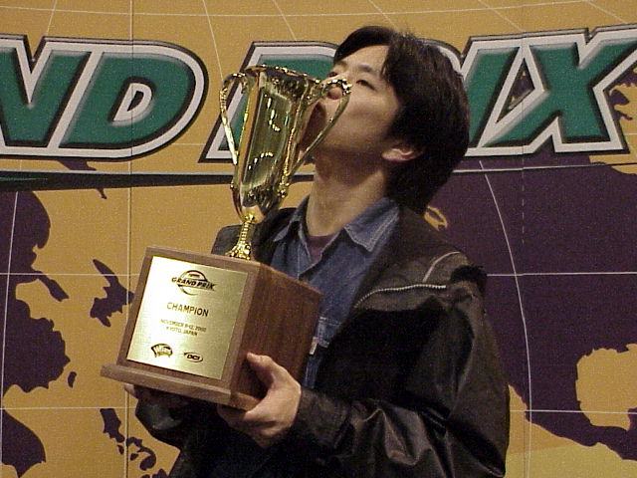
Although Trix did not succeed in Phoenix, it did dominate the much larger GP Kyoto held that same weekend. With over 700 competitors, Kyoto was a large event even for a Japanese tournament. Tsuyoshi Fujita, who has had a number of Top 16 finishes and other close calls in the past, was finally able to achieve his first career win by defeating Yuki Murakami in the finals Trix mirror match. Canadian Ryan Fuller and ex-American (and now Taiwanese) Tobey Tamber were the only foreign players to make Top 8 of this tournament, and were the first non-Japanese players to ever make a Top 8 of an individual Japanese Grand Prix. (previously Team Grand Prix: Nagoya was the only event where foreign players managed to break into the top 8 in Japan). Fuller played a modified Survival deck similar to that used by Bob Maher in the Masters Series while Tamber surprised everyone by navigating a Stompy deck into the Top 8.
GP Sydney followed a week later. Players had studied the results from the previous two events, but a different archetype won here. Gordon Lin, one of a number of players to travel to the event from New Zealand, won the tournament with a Pandeburst deck, otherwise known as "21" or "Blackjack." The deck wins by using Replenish to get both Pandemonium and Saproling Burst into play. This combo allows its caster to immediately deal 21 points of damage. He defeated a CounterSliver deck in the finals, with TurboLand (traditional 2 color version) and Trix completing the top 4.
You can learn more about these events by following these links:
GP Phoenix: www.wizards.com/sideboard/event.asp?event=GPPHX00
GP Kyoto: www.wizards.com/sideboard/event.asp?event=GPKYO00
GP Sydney: www.wizards.com/sideboard/event.asp?event=GPSYD00

Magic Invitational 2000
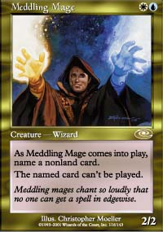
The most important Magic event of the month was clearly the Magic Invitational, held in Sydney. This annual tournament showcases the top 16 players in the world. Although most players feel that it is more important to compete than to win, no one wants to finish last. Last year, Chris Pikula defeated Jon Finkel in the finals with Gary Wise ending up in the last place. Pikula's prize for finishing first was to design his own Magic card. The event was opened by unveiling Pikula's card - Meddling Mage - a gold creature for WU that allows its caster to prevent an opponent from playing any one spell as long as the Mage remains in play.
After 15 rounds of fierce competition across five different formats, Jon Finkel faced Ben Rubin in the finals. Finkel has had an amazing year, snatching both U.S. National and World Championship titles. Rubin, while an amazing competitor, is known for finishing in the second place. Their final match was no different, with Finkel defeating his opponent. Finkel only needs to add a Masters Series win to complete his resume and no one will be surprised if he manages that this season. Last place this year went to Zvi Mowshowitz, despite the fact that he spent more time preparing for this event than most of the other competitors. Mark Rosewater, the creator and organizer of Magic Invitational, pointed out that over the couse of the last two years a person to finish last in the Invitational have gone on to win a Pro Tour. Will Mowshowitz follow suit and turn this defeat into a blessing? Time will tell.
Detailed coverage of the Magic Invitational can be found here: www.wizards.com/sideboard/event.asp?event=MI00

Happy Birthdays

Part of the fun of attending events like the Magic Invitational is learning more about fellow players and WOTC staff attending the event. We figured out a cool chain of birthdays was slated to happen right after the Invitational. My own birthday is on November 19, the Finals day of the tournament (I turned 25). Following me is Sideboard's editor Omeed Dariani's birthday on Monday, November 20 and R&D's Randy Buehler's birthday on Tuesday, November 21. Happy birthdays!

Best of the Net
Quality articles have been a bit dry around the net lately, but that does not mean you cannot find quality information out there. Perhaps the most useful to players out there are currently the winning deck lists from the State Championships. Neutralground.net posted the top 8 deck lists from the 4 State Championships ran by them, including lists by pros like Chris Pikula and Mike Turian. You can find the lists here: www.neutralground.net/Live/States2000/Top8.asp. There are also many decklists on the Sideboard, at www.wizards.com/sideboard/article.asp?x=sb20001106b. In the meantime, Mindripper presents the report of the Nordic Championship winner Mattias Jorstedt over here: magic.mindripper.com/Index.cfm?ArticleID=1078&SectionID=3&Show=All

Charity Auction of Champions

One of the formats at the Magic Invitational was an Auction of Champions, where the 16 players bid life points and opening hand size on the decks that have previously won Pro Tour (17 in all). The cards for this portion of the event were graciously provided by www.StarCityGames.com. Each player had to sign the entire deck before returning it to the organizers. These decks will soon be auctioned off on www.Ebay.com, with a portion of the proceeds going to charity.
We will bring you more information about this auction once it begins.

Your Mana's Worth
NecroDonate being the most popular deck, it is important to understand its strengths as well as its weaknesses. I was surprised to learn how many people at the Grand Prix tournaments seemed unaware that when Illusions of Grandeur come into play, the life gain effect goes on the stack and can be responded to.
If your opponent casts Illusions, you may respond by casting Emerald Charm, Pyroblast, or using your Seal of Cleansing. Since this effect is added to the stack after the life gain effect, it will resolve first, resulting in the caster of Illusions losing 20 life. He will therefore lose the game before he ever has a chance of gaining life from Illusions.

Play of the Week
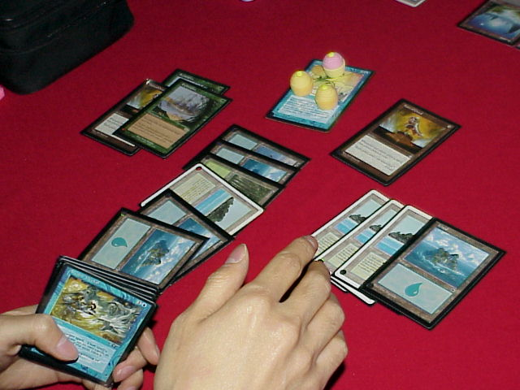
Satoshi Nakamura is possibly the only player in the world to have played TurboLand even more than its creator Zvi Mowshowitz. This Japanese player has navigated TurboLand to Top 8 finishes in GP Taipei last season as well as GP Sydney last weekend.
Most Trix players think their job is done once they Donate the nasty enchantment to their opponents. Not so in case of Mr. Nakamura. With multiple Explorations in play, Nakamura managed to successfully pay upkeep on Illusions of Grandeur for as long as 5-6 turns, managing to defeat his opponent in the meantime!
Got a Play of the Week of your own? Have any other interesting news or rumors that might belong in the next week's column? Please e-mail me at ashv@concentric.net

